X International Festival of Puppetry Schools

PUPPETNOPUPPET

APPLICATION FORM

Organizers:
Aleksander Zelwerowicz National Academy of Dramatic Art in Warsaw
Białystok Association of Puppeteers
Białystok Puppet Theatre
Follow us:
https://atb.edu.pl/festiwal/ https://www.facebook.com/AkademiaTeatralnaBialystok https://www.instagram.com/akademiateatralnabialystok/ https://www.youtube.com/c/AkademiaTeatralnaBia%C5%82ystok

The Festival is organized thanks to the financial support of the Polish Ministry of Education and Science and the City of Białystok.
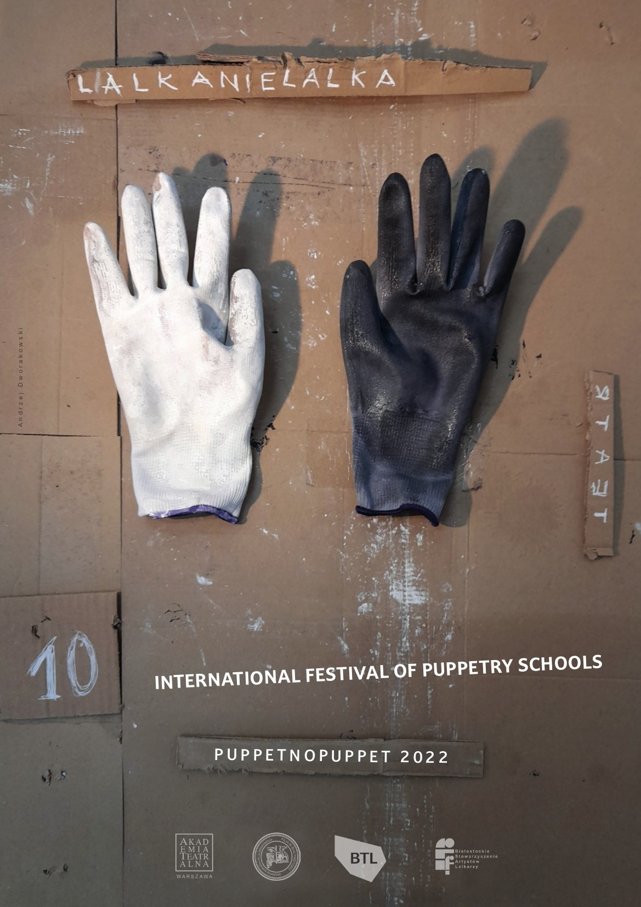

ABOUT THE FESTIVAL, ITS HISTORY AND IDEA
The International Festival of Puppetry Schools PUPPETNOPUPPET is one of the most durable academic and cultural traditions in Poland: it has been held in Białystok every two years since 2002. In 2022, we will celebrate a double jubilee: the 10th edition of the event on the 20th anniversary of its establishment (due to the pandemic, the festival was not held in 2020). The festival is organized in the only one Polish city associated with the Association des Villes Amies de la Marionnette (the so-called Union of Puppetry Cities) and one of the two – next to Wrocław – Polish cities where professional creators of the puppetry theatre are educated.
The jubilee edition is the crowning achievement of two decades of academic and cultural tradition.
However, we still strive for making the event an open space for inspiration and experiment. Therefore, the idiom of the 2022 Festival is labōrATōrium, referring to the Latin ‘workshop’, to the universal consonance for various languages and to the imagination as the universal work tool of theatre creators around the world. In this idiom, we want to express the constant striving to discover new meanings in the theatre space and emphasize the research, scientific dimension of the event, less obvious to many recipients.
The jubilee edition of the International Festival of Puppetry Schools PUPPETNOPUPPET will take place in Białystok on June 21-25, 2022. It is organized by The Aleksander Zelwerowicz National
Academy of Dramatic Art in Warsaw – Branch Campus in Białystok, together with the Białystok Puppeteers Association and the Białystok Puppet Theatre. The Festival traditionally presents performances in two streams: professional and student.
Prof. Marta Rau, Vice-Rector of the Academy, Art Director of the Festival:
I would like this jubilee event to reflect on the place of puppet theatre in the current reality and give the opportunity to enjoy creativity
in the most beautiful, in my opinion, art field.
Let’s be the creators of this Festival together!

GENERAL TERMS
performances
Each theatre school can submit two proposals:
- performance that is a completed theatrical work (no longer than 90 minutes),
- additional presentation: etude, presentation of educational methods or other forms of public show (laboratory, work in progress), duration 5-60 minutes.
You can apply with a show that is still under preparation, but we still require a detailed description on the forms attached below. Each school may be represented by no more than 13 people
(students, educators, drivers). Additional participants may be included, but the cost of their stay (accommodation, meals etc.) must be covered by the applying school. The school also grants copyrights to productions, including consent to the recording of fragments of the performance for PR purposes and possible consent to the online presentation (YouTube) – if it is not be possible to organize the Festival in its full form. Participating schools will pay for travel, customs, transportation, props and possible Sars-Cov-2 tests costs.
other forms
We are also open for the additional proposals, which are not performances but are linked to the theatre of object, puppet theatre etc., i.e. exhibitions, installations, small concerts, videos. If you want us to consider such a proposal, please fill the last attachment. NOTICE: You can propose such a form even if you are not applying to the main program with the performance. There is no special remuneration for additional proposals.
We recommend purchasing a special travel insurance including possible costs of quarantine in Poland for the entire group, including accommodation, meals, and tickets changes.
The Academy will not be able to cover these expenses for you.

WE ENSURE:
- remuneration: PLN 5000 gross for festival presentations (2 forms),
- free admission to all Festival performances and other events according to the program,
- accommodation in hotels in the centre of Białystok (parking included),
- lunches in two options: vegan and traditional,
- festival package for each participant of the Festival,
- a package books for each school (to the library),
- technical and organizational assistance during the assembly and disassembly of stage set-up,
- support with travel formalities (invitations, visas, Sars-Cov-2 procedures etc.), • assistance in organizing Sars-Cov-2 tests (procedures, certificated points).
If you agree to all of that, complete and submit the application form (attached templates) and send it by February 28, 2022 to the address: festival@e-at.edu.pl.
All proposals will be considered by the Festival Scientific Committee:
- prof. Marta Rau – Vice-Rector of the Aleksander Zelwerowicz National Academy of Dramatic Art in Warsaw Branch – Campus in Białystok
- dr Karol Suszczyński – president of Białystok Puppeteers Associations
- dr hab. Jacek Malinowski – director of Białystok Puppet Theatre, president of POLUNIMA
- dr Bernarda Bielenia – board member of POLUNIMA
- dr hab. Artur Dwulit – dean of the Academy
- dr Mateusz Smaczny – pedagogue of the Academy
- dr Jacek Dojlidko – pedagogue of the Academy
- dr Łucja Grzeszczyk – pedagogue of the Academy
- Tymoteusz Sarosiek – student of the Academy.

CHECKLIST FOR THE APPLICATION FORM
- Letter of confirmation
- Information about the school
- Information about the 1st performance
- Technical requirements of the 1st performance
- Attachments to the 1st performance.
- Information about the 2nd performance
- Technical requirements of the 2nd performance
- Attachments to the 2nd performance
- Other proposals.

You must complete and send in PDF format all the information listed above, in particular the letter of confirmation – printed, signed by the authority, scanned and added to the mail. Our address: festival@e-at.edu.pl. Editable forms are attached to the mail and available on our website.

THE LETTER OF CONFIRMATION
click to enter text
click to enter text
Address:
click to enter text
Tel.: click to enter text (with the country code before the number)
E-mail: click to enter text
Tax Identification Number (or related): click to enter text
Authority (titles, name, position): click to enter text

I confirm that we have read the conditions of participation in the 10. International Festival of Puppetry Schools PUPPETNOPUPPET 2022 and we accept them all. In particular, I confirm that we will cover the costs of travel, customs, transport of props and possible costs related to the current pandemic situation (especially tests, quarantine).
I confirm that we have obtained copyright permission for our production: click to enter text (title original and in English) and that the organizers of the Festival will not incur unplanned expenses to cover copyright fees connected with the presentation of our performance during the Festival or online – if it is not be possible to organize the Festival in its full form.

Place, date (day/month/year), signature and the stamp of the official representative:
click to enter text

INFORMATION ABOUT THE SCHOOL
Name of the school: click to enter text
Status of the school: private ☐ public ☐
Department: click to enter text
Street: click to enter text
PC: click to enter text
City: click to enter text
Country: click to enter text
Tel.: click to enter text
E-mail: click to enter text
Website: click to enter text
FB: click to enter text
INSTA: click to enter text
YouTube: click to enter text
Contact person (name, e-mail, phone number): click to enter text
Describe your school, its main activities and achievements (no less than 500, no more than 1000 characters with spaces):
click to enter text

INFORMATION ABOUT THE 1ST PERFORMANCE
Original name of the performance
Name of the performance in English
Author
Translator
Full time of the performance
Intervals (if there are some)
The date of the opening night
Director
Dramaturge
Set
Costumes
Music
Light design
Choreography
Cast
Others
Can you deliver a digital version of the show for online presentation? We treat it as an optional solution if it is not possible to organise the Festival in its full form. | YES ☐ NO ☐
 | live streaming ☐ digital video file ☐
ANNOTATION (no less than 100, no more than 500 characters with spaces):

TECHNICAL REQUIREMENTS FOR THE 1ST PERFORMANCE
NOTICE! Please, include lighting plan or any other tech drafts.
Stage space required |  |  | width |  |  |  | depth |  | height
1. floor level ☐ 2. on podiums ☐ size text 3. on a standard stage ☐
Audience | 1. amphitheatrically / classical ☐ 2. floor level ☐ 3. does not matter ☐ other:
Necessary stage equipment (dance floor, coverage etc.)
Followspot |  |  | YES ☐ NO ☐
Minimum number of lighting circuits
Lights (type of fixture and quantity)
Gels |  |  | You have to bring your own gels.
Projections (number of projectors, details of the surface you use etc.)
Sound console details |  |  | input channels |  |  |  |  | output channels
Other sound requirements (CD player, microphone, microport etc.)
Are you technically self-sufficient? |  | YES ☐ NO ☐  describe your requires:
Full time of the performance
Intervals (if there are some)
Estimated time for lighting set-up (in minutes)
Estimated time for sound set-up (in minutes)
Time for removing the set
Set-up time in total
Do you need time for rehearsal? |  |  |  |  | YES ☐ NO☐ if so, how long?
Other helpful information

ATTACHMENTS TO THE 1ST PERFORMANCE
OBLIGATORY
- 3-6 photos ☐
- link to the recording ☐

OPTIONAL
- reviews ☐
- posters ☐
- additional information if necessary ☐

If you are proposing a performance that is under development, add as much information and materials as possible (from rehearsals).

NOTICE: Without OBLIGATORY attachments, the Scientific Committee cannot consider your application.

INFORMATION ABOUT THE 2ND PERFORMANCE
Original name of the performance
Name of the performance in English
Author
Translator
Full time of the performance
Intervals (if there are some)
The date of the opening night
Director
Dramaturge
Set
Costumes
Music
Light design
Choreography
Cast
Others
Can you deliver a digital version of the show for online presentation? We treat it as an optional solution if it is not possible to organise the Festival in its full form. | YES ☐ NO ☐
 | live streaming ☐ digital video file ☐
ANNOTATION (no less than 100, no more than 500 characters with spaces):

TECHNICAL REQUIREMENTS FOR THE 2ND PERFORMANCE
NOTICE! Include lighting plan or any other tech drafts.
Stage space required |  |  | width |  |  |  | depth |  | height
1. floor level ☐ 2. on podiums ☐ size text 3. on a standard stage ☐
Audience | 1. amphitheatrically / classical ☐ 2. floor level ☐ 3. does not matter ☐ other:
Necessary stage equipment (dance floor, coverage etc.)
Followspot |  |  | YES ☐ NO ☐
Minimum number of lighting circuits
Lights (type of fixture and quantity)
Gels |  |  | You have to bring your own gels
Projections (number of projectors, details of the surface you use etc.)
Sound console details |  |  | input channels |  |  |  |  | output channels
Other sound requirements (CD player, microphone, microport etc.)
Are you technically self-sufficient? |  | YES ☐ NO ☐  describe your requires:
Full time of the performance
Intervals (if there are some)
Estimated time for lighting set-up (in minutes)
Estimated time for sound set-up (in minutes)
Time for removing the set
Set-up time in total
Do you need time for rehearsal? |  |  |  |  | YES ☐ NO☐ if so, how long?
Other helpful information

ATTACHMENTS TO THE 2ND PERFORMANCE
OBLIGATORY
- 3-6 photos ☐
- link to the recording ☐

OPTIONAL
- reviews ☐
- posters ☐
- additional information if necessary ☐

If you are proposing a performance that is under development, add as much information and materials as possible (from rehearsals).

NOTICE: Without OBLIGATORY attachments, the Scientific Committee cannot consider your application.

ATTACHMENT – OTHER PROPOSAL
Authors
Form
Duration
Presented… | online ☐ offline ☐ both ☐
Space requirements
Other requirements
Description (annotation)

NOTICE: Add some photos or links if possible.

* financial settlement on the basis of an agreement between universities/organisations, payable after issuing an invoice

